Jaleel Calhoun

Intro:

The objectives for this lab is to add a home gateway to the network, connect IoT devices wirless to network, add an end user device to network, add a registration server to the network, and register IoT devices to the registration server.

Description:

**Part 1: Connect a Home Gateway to the Network**

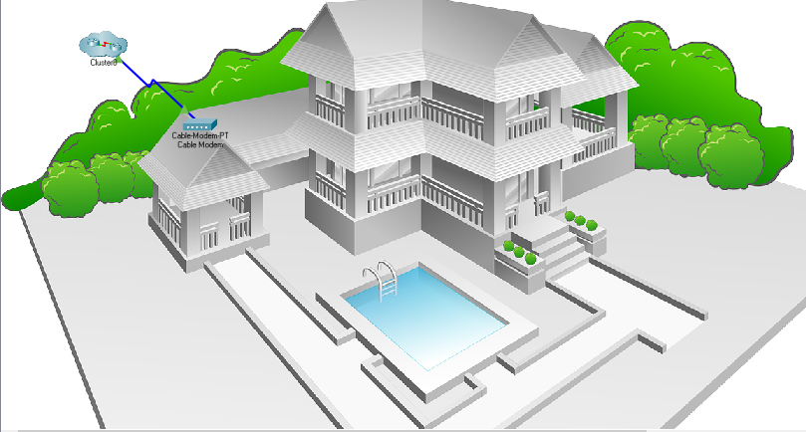

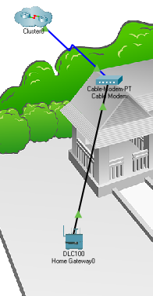

**Part 2: Connect IoT Devices to the Wireless Network**

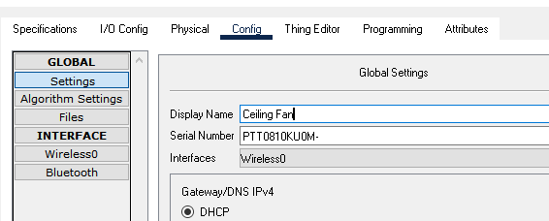

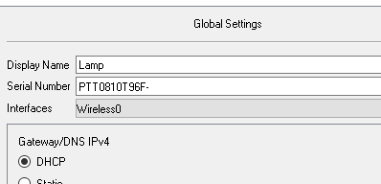

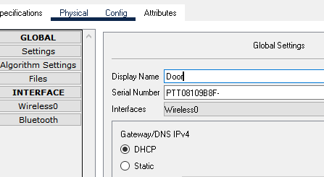

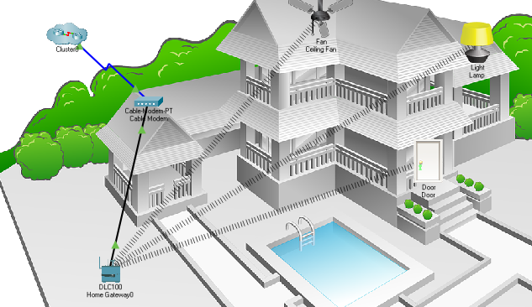

**Part 3: Add a Wireless Tablet to the Network**

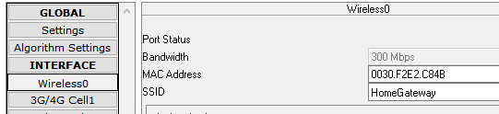

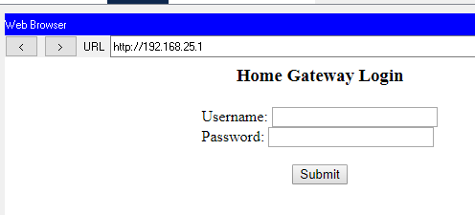

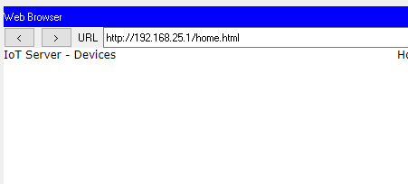**None at first**

**Step 3:**

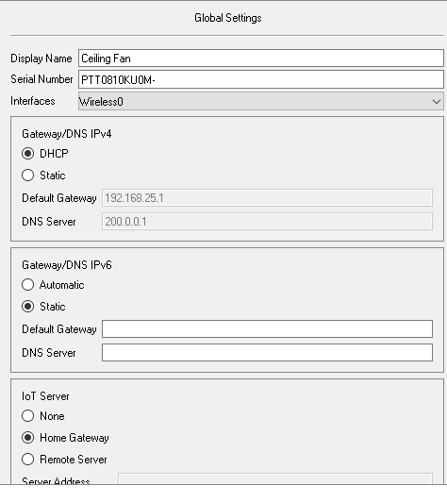**Repeated steps for door and lamp**

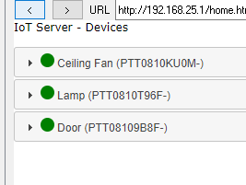**Now able to see IoT service devices**

**Other part of lab:**

**Part 1: Add a Registration Server to the Network**

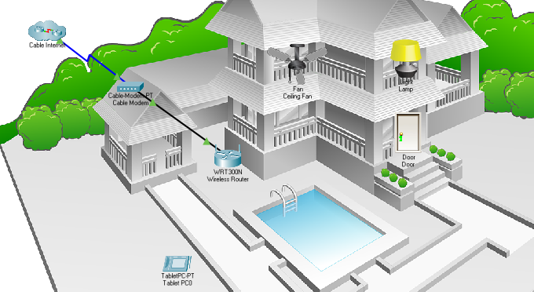

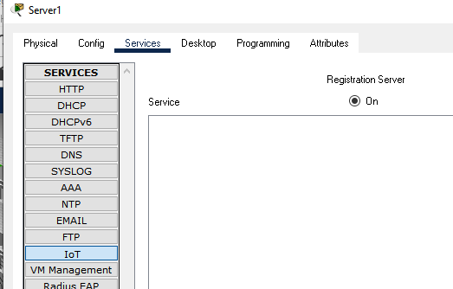

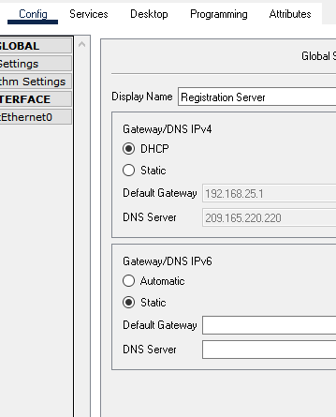

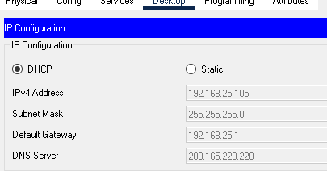

**Part 2: Register Devices to the Registration Server**

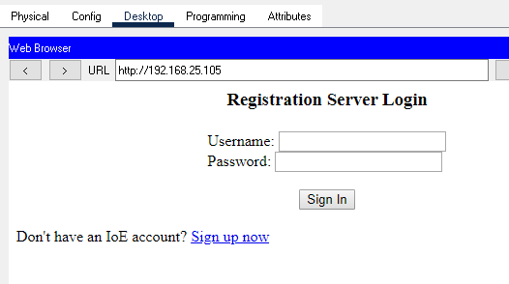

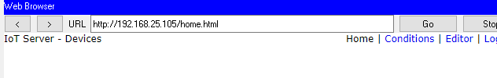

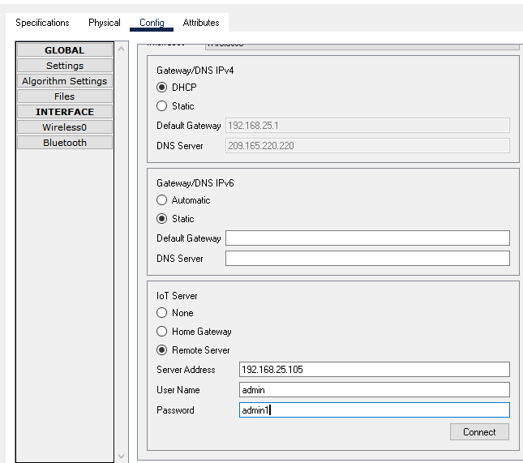For fan and repeat steps for lamp, door

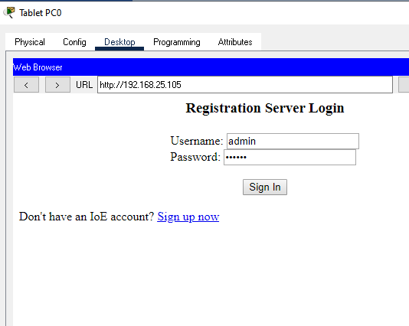

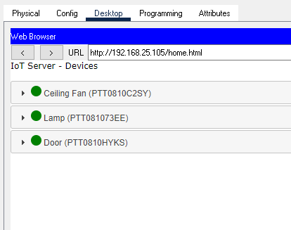

Conclusion:

In conclusion, I was able to learn how to add a home gateway to the network, connect IoT devices wirless to network, add an end user device to network, add a registration server to the network, and register IoT devices to the registration server on packet tracer.